**Tutorial 02**

We are learning here, how to move an object from using the WASD. It is not that hard, an easy script to make.

* First create a cube and scale it to look like a Ground.
* Then create a cube and tag it as Player. If you like you can add materials to both the objects so that they can be identified apart.
* Add a Rigidbody component to the Player Object. (Add a component > Rigidbody)
* Now add a c sharp script to the Player from Add a Component > C sharp script. And name it as PlayerMovement. Now open the script from MonoDevelopment or Visual Studio.

*Now the coding part…*

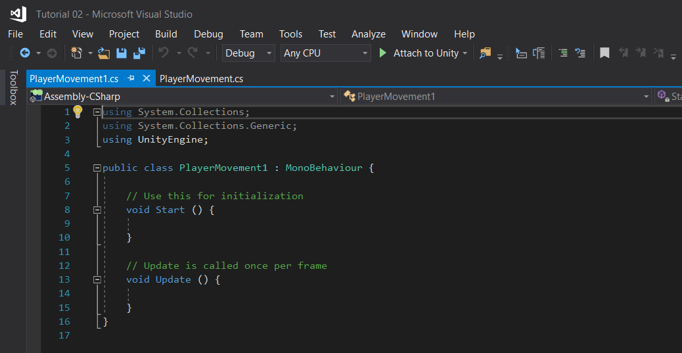

For this script you don’t need the “start” function. So if you prefer you can delete the start function. 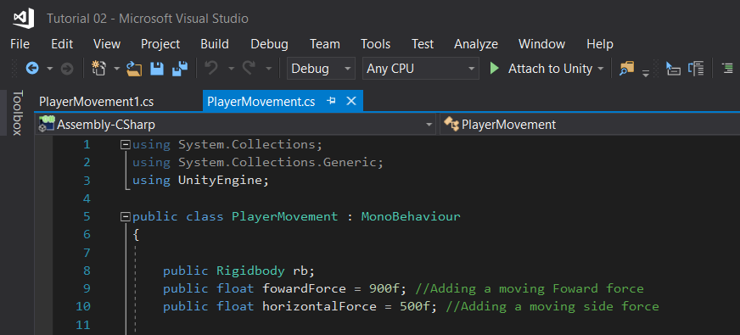

Here you can see I have called Rigidbody, and now the Player Rigidbody should be added into the script from Unity.

Next, I have added forward force and Horizontal force, Make it public so you can edit it from Unity. 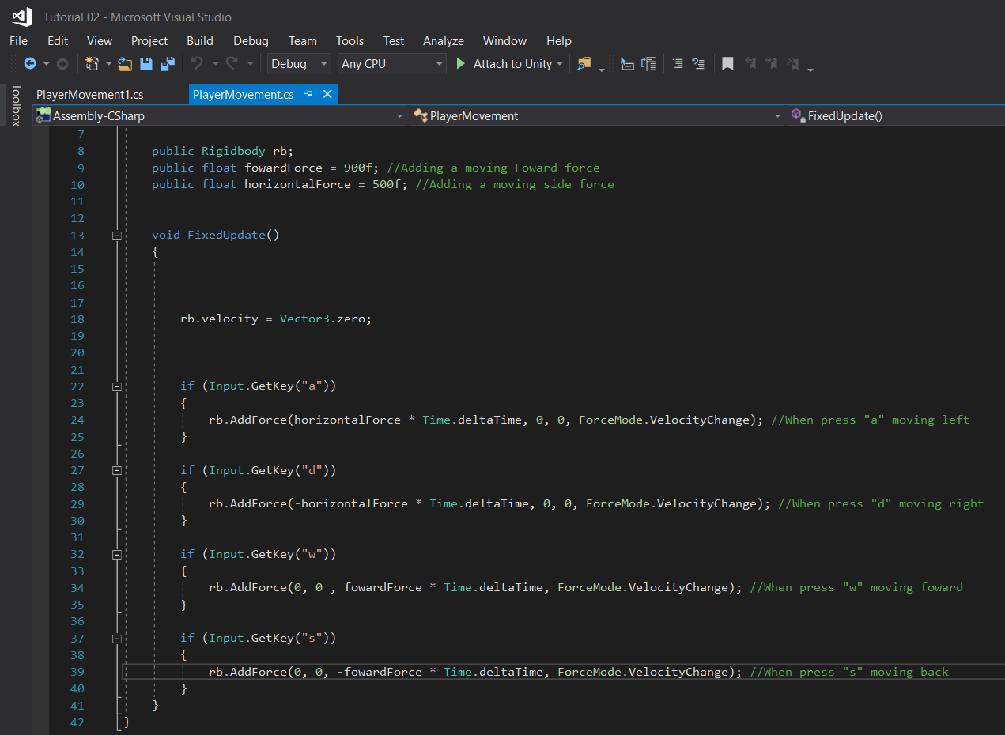

Make the Update function FixUpdate in this case. Under this we are making the Movement done. As you can see, I have used “if” statements for this, there might be easy ways to do this rather than this, but this is my version of doing it.

By Input.GetKey we are calling the “a” key, and the in the if statement we are adding a horizontal force to the “x” axis because we want the Player to move left when press “a”. We don’t need values to “y” and “z” axis.

***What is Time.deltatime?***

The **time** in seconds it took to complete the last frame (Read Only). Use this function to make your game frame rate independent. If you add or subtract to a value every frame chances are you should multiply with **Time**.**deltaTime**. ... When called from inside MonoBehaviour's FixedUpdate, returns the fixed framerate **delta time**.

Do the same thing to “d” key. But make the value on the “x” axis minus.

Now copy the same thing to “w” and “s” but add the values to “z” axis instead of “x” axis. Because we want the Player to move forward and back when pressed “w” and “s”.

Now we are done with the Coding. Go to Unity.

Add the Rigidbody Component under PlayerMovement script rb.

And now we are practically done. Now you have learned how to move your Player by WASD.

Enjoy!

Lakshitha Abeyrathna